MA4832 Microprocessor Systems
Lab Exercise – Analog-to-Digital Converter

In this session, you will learn how to
- Use Port E as an A/D converter
- Display the analog signal of a temperature sensor on an oscilloscope
- Store converted digital readings of temperature sensor and rotary potentiometer into predefined addresses
- Switch between multi-channel and single-channel modes

- Multi-channel mode

- Schematic of the sample circuit is shown in Fig. 1.
- Program: adc_two_ch.s

; adc_two_ch.s
; samples two ADC channels, PortE bit 4 (PE4) and bit 5 (PE5), using Sample Sequencer 2 (SS2)

; GPIO_PORTE and ADC0 address

GPIO_PORTE_AFSEL_R EQU 0x40024420
GPIO_PORTE_DEN_R EQU 0x4002451C
GPIO_PORTE_AMSEL_R EQU 0x40024528

ADC0_ACTSS_R EQU 0x40038000
ADC0_PC_R EQU 0x40038FC4
ADC0_SSPRI_R EQU 0x40038020
ADC0_EMUX_R EQU 0x40038014
ADC0_SSMUX2_R EQU 0x40038080
ADC0_SSCTL2_R EQU 0x40038084
ADC0_IM_R EQU 0x40038008
ADC0_PSSI_R EQU 0x40038028
ADC0_RIS_R EQU 0x40038004
ADC0_SSFIFO2_R EQU 0x40038088
ADC0_ISC_R EQU 0x4003800C

SYSCTL_RCGCGPIO_R EQU 0x400FE608 ; GPIO run mode clock gating control

SYSCTL_RCGCADC_R EQU 0x400FE638 ; ADC run mode clock gating control

THUMB
AREA DATA, ALIGN=4
EXPORT Result [DATA,SIZE=4]
Result SPACE 4

AREA |.text|, CODE, READONLY, ALIGN=2
THUMB
EXPORT Start

Start

; initialize Port E
; activate clock for PortE

LDR R1, =SYSCTL_RCGCGPIO_R ; R1 = &SYSCTL_RCGCGPIO_R
LDR R0, [R1] ;
ORR R0, R0, #0x10 ; turn on GPIOE clock
STR R0, [R1]
NOP ; allow time for clock to finish
NOP
NOP

; no need to unlock PE4 and PE5

; select alternate function
LDR R1, =GPIO_PORTE_AFSEL_R
LDR R0, [R1]
ORR R0, R0, #0x30 ; enable alternate function on PE4 and PE5
STR R0, [R1]

; disable digital port
LDR R1, =GPIO_PORTE_DEN_R
LDR R0, [R1]
BIC R0, R0, #0x30 ; disable digital I/O on PE4 and PE5
STR R0, [R1]

; enable analog functionality
LDR R1, =GPIO_PORTE_AMSEL_R
LDR R0, [R1]
ORR R0, R0, #0x30 ; enable PE4 analog function
STR R0, [R1]

; activate clock for ADC0
LDR R1, =SYSCTL_RCGCADC_R
LDR R0, [R1]
ORR R0, R0, #0x01 ; activate ADC0
STR R0, [R1]

BL Delay ; delay subroutine -> allow time for clock to finish

LDR R1, =ADC0_PC_R
LDR R0, [R1]
BIC R0, R0, #0x0F ; clear max sample rate field
ORR R0, R0, #0x1 ; configure for 125K samples/sec
STR R0, [R1]

LDR R1, =ADC0_SSPRI_R
LDR R0, =0x1023 ; SS2 is highest priority
STR R0, [R1]

LDR R1, =ADC0_ACTSS_R
LDR R0, [R1]
BIC R0, R0, #0x0004 ; disable SS2 before configuration to
STR R0, [R1] ; prevent erroneous execution if a trigger event
; were to occur

LDR R1, =ADC0_EMUX_R
LDR R0, [R1]
BIC R0, R0, #0x0F00 ; SS2 is software trigger
STR R0, [R1]

LDR R1, =ADC0_SSMUX2_R
LDR R0, [R1]
BIC R0, R0, #0x00FF ; clear SS2 field
ADD R0, R0, #0x89 ; set channel -> select input pin AIN8 and AIN9
STR R0, [R1]

LDR R1, =ADC0_SSCTL2_R
LDR R0, =0x0060 ; configure sample -> not reading Temp sensor,
; not differentially sampled,
STR R0, [R1] ; assert raw interrupt signal at the end of
; conversion, second sample is last sample

LDR R1, =ADC0_IM_R
LDR R0, [R1]
BIC R0, R0, #0x0004 ; disable SS2 interrupts
STR R0, [R1]

LDR R1, =ADC0_ACTSS_R
LDR R0, [R1]
ORR R0, R0, #0x0004 ; enable SS2
STR R0, [R1]

Loop
LDR R1, =ADC0_PSSI_R
MOV R0, #0x04 ; initiate sampling in SS2
STR R0, [R1]

LDR R1, =ADC0_RIS_R ; R1 = address of ADC Raw Interrupt Status
LDR R0, [R1] ; check end of a conversion
CMP R0, #0x04 ; when a sample has completed conversion -> a raw
; interrupt is enabled

BNE Loop

LDR R1, =ADC0_SSFIFO2_R ; load SS2 result FIFO into R1
LDR R2, =Result
LDR R0,[R1]
STR R0,[R2] ; store PE4 reading in addr 0x20000000 & 0x20000001

LDR R0,[R1]
ADD R2, R2, #04
STR R0,[R2] ; store PE5 reading in addr 0x20000004 & 0x20000005

LDR R1, =ADC0_ISC_R
LDR R0, [R1]
ORR R0, R0, #04 ; acknowledge conversion
STR R0, [R1]

B Loop

Delay ; Delay subroutine
MOV R7,#0x0F

Countdown
SUBS R7, #1 ; subtract and set the flags based on the result
BNE Countdown

BX LR ; return from subroutine

ALIGN ; make sure the end of this section is aligned
END ; end of file

- Load and run the program.
- Observe the following points:
        - The analog voltage reading from the temperature sensor is displayed on the oscilloscope. Use a small screwdriver to adjust the blue 10K trimmer such that reading is 0 volts at room temperature.
        - By pressing the temperature sensor with your thumb and finger, the temperature sensed would rise from ambient temperature (about 22°C) to near body temperature (about 35°C).
        - Use the graph on Fig. 2 to relate voltage to temperature.
        - After conversion, the digital readings of the temperature sensor and rotary potentiometer are stored at addresses 0x20000000 (low byte) & 0x20000001(high byte) and 0x20000004 (low byte) & 0x20000005 (high byte) respectively
        - Watch these digital values change as temperature changes or as you turn the rotary potentiometer.

  - Single Channel Mode

- Schematic of the sample circuit is the same as Fig. 1.
- Program: adc_single_ch.s

; adc_single_ch.s
; samples one ADC channel, PortE bit 4 (PE4), using Sample Sequencer 3(SS3)

; GPIO_PORTE and ADC0 address

GPIO_PORTE_AFSEL_R EQU 0x40024420
GPIO_PORTE_DEN_R EQU 0x4002451C
GPIO_PORTE_AMSEL_R EQU 0x40024528

ADC0_ACTSS_R EQU 0x40038000
ADC0_PC_R EQU 0x40038FC4
ADC0_SSPRI_R EQU 0x40038020
ADC0_EMUX_R EQU 0x40038014
ADC0_SSMUX3_R EQU 0x400380A0
ADC0_SSCTL3_R EQU 0x400380A4
ADC0_IM_R EQU 0x40038008
ADC0_PSSI_R EQU 0x40038028
ADC0_RIS_R EQU 0x40038004
ADC0_SSFIFO3_R EQU 0x400380A8
ADC0_ISC_R EQU 0x4003800C

SYSCTL_RCGCGPIO_R EQU 0x400FE608 ; GPIO run mode clock gating control

SYSCTL_RCGCADC_R EQU 0x400FE638 ; ADC run mode clock gating control

THUMB
AREA DATA, ALIGN=4
EXPORT Result [DATA,SIZE=4]
Result SPACE 4

AREA |.text|, CODE, READONLY, ALIGN=2
THUMB
EXPORT Start

Start
; initialize Port E
; activate clock for PortE

LDR R1, =SYSCTL_RCGCGPIO_R ; R1 = &SYSCTL_RCGCGPIO_R
LDR R0, [R1] ;
ORR R0, R0, #0x10 ; turn on GPIOE clock
STR R0, [R1]
NOP ; allow time for clock to finish
NOP
NOP

; no need to unlock PE4

; enable alternate function
LDR R1, =GPIO_PORTE_AFSEL_R
LDR R0, [R1]
ORR R0, R0, #0x10 ; enable alternate function on PE4
STR R0, [R1]

; disable digital port
LDR R1, =GPIO_PORTE_DEN_R
LDR R0, [R1]
BIC R0, R0, #0x10 ; disable digital I/O on PE4
STR R0, [R1]

; enable analog function
LDR R1, =GPIO_PORTE_AMSEL_R
LDR R0, [R1]
ORR R0, R0, #0x10 ; enable PE4 analog function
STR R0, [R1]

; activate clock for ADC0
LDR R1, =SYSCTL_RCGCADC_R
LDR R0, [R1]
ORR R0, R0, #0x01 ; activate ADC0
STR R0, [R1]

BL Delay ; delay subroutine -> allow time for clock to finish

LDR R1, =ADC0_PC_R
LDR R0, [R1]
BIC R0, R0, #0x0F ; clear max sample rate field
ORR R0, R0, #0x1 ; configure for 125K samples/sec
STR R0, [R1]

LDR R1, =ADC0_SSPRI_R
LDR R0, =0x0123 ; SS3 is highest priority
STR R0, [R1]

LDR R1, =ADC0_ACTSS_R
LDR R0, [R1]
BIC R0, R0, #0x08 ; disable SS3 before configuration to
STR R0, [R1] ; prevent erroneous execution if a trigger event were to occur

LDR R1, =ADC0_EMUX_R
LDR R0, [R1]
BIC R0, R0, #0xF000 ; SS3 is software trigger
STR R0, [R1]

LDR R1, =ADC0_SSMUX3_R
LDR R0, [R1]
BIC R0, R0, #0x000F ; clear SS3 field
ADD R0, R0, #9 ; set channel -> select input pin AIN9
STR R0, [R1]

LDR R1, =ADC0_SSCTL3_R
LDR R0, =0x0006 ; configure 1st sample -> not reading Temp sensor,
; not differentially sampled,
STR R0, [R1] ; assert raw interrupt signal at the end of
; conversion, first sample is last sample

LDR R1, =ADC0_IM_R
LDR R0, [R1]
BIC R0, R0, #0x0008 ; disable SS3 interrupts
STR R0, [R1]

LDR R1, =ADC0_ACTSS_R
LDR R0, [R1]
ORR R0, R0, #0x0008 ; enable SS3
STR R0, [R1]

Loop
LDR R1, =ADC0_PSSI_R
MOV R0, #0x08 ; initiate sampling in SS3
STR R0, [R1]

LDR R1, =ADC0_RIS_R ; R1 = address of ADC Raw Interrupt Status
LDR R0, [R1] ; check end of a conversion
CMP R0, #0x08 ; when a sample has completed conversion -> a raw
; interrupt is enabled
BNE Loop

LDR R1, =ADC0_SSFIFO3_R ; load SS3 result FIFO into R1
LDR R0,[R1]
LDR R2, =Result
STR R0,[R2]

LDR R1, =ADC0_ISC_R
LDR R0, [R1]
ORR R0, R0, #08 ; acknowledge conversion
STR R0, [R1]

B Loop

Delay ; Delay subroutine
MOV R7,#0x0F

Countdown
SUBS R7, #1 ; subtract and set the flags based on the result
BNE Countdown

BX LR ; return from subroutine

ALIGN ; make sure the end of this section is aligned
END ; end of file

- Load and run the program
- Observe the following points:
        - Only the temperature sensor reading has been converted.
        - The sampling control and data capture is handled by the Sample Sequencer 3 (SS3).

Exercise 1:

For sample program 2, “adc_single_ch.s”, replace the temperature transducer with the potentiometer (pot), i.e. now you are reading from PE5, not PE4.
Modify the sample program 2 such that

- When the pot output rises beyond 1.0V, the on-board green LED (PortF 3) would start to flicker. When the pot output voltage rises beyond 2.0V, the red LED (PortF 1) would start to flicker (Turn off Green LED). When the voltage falls back to below 2.0V, the red LED is turned off. Falling below 1.0V would turn off the green LED too.

Exercise 2:

Modify the Exercise 1 program to sample and capture data from PE5 using Sample
Sequencer 1 (SS1)

FF 0F – 3.3 V
DE 04 – 1
A3 09 - 2
8F 0E - 3
00 00 - 0V

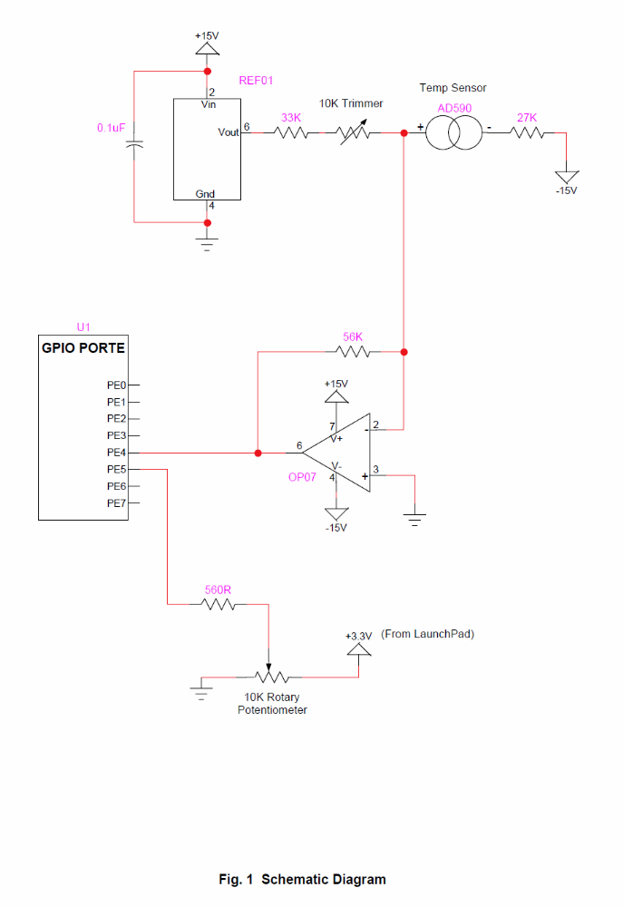

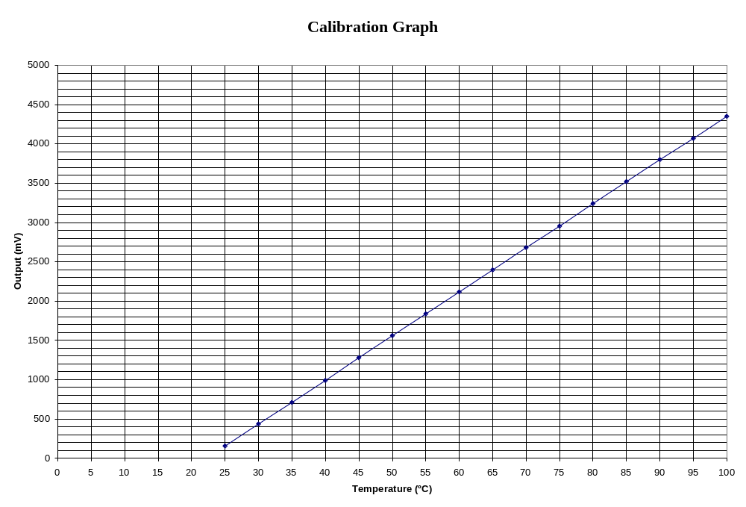
Fig. 2

